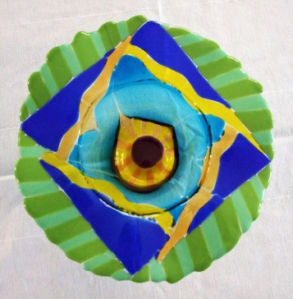

Zachary Millsap
Date of Birth-Sept. 17, 1991
1433 E Browning Ave., Sandy, Utah 84092
(801) 971-6599
zachmillsap@gmail.com

EDUCATION

2010-Present
Physics Major
Sophomore, University of Utah, Salt Lake City, Utah

2010
High School Diploma
Alta High School

INTERESTS and SKILLS

- Current CPR Certification
- Current Food Handler’s Permit
- Art & Science
- Glass fusing and mosaics
- Mountain and water sports
- Renewable energy
- Working with children
- Microsoft office
- Auto CAD

PROFESSIONAL EXPERIENCE

2007- 2009

Life guard, Alta Canyon Recreation Center, Sandy, Utah
- Pool safety, rule enforcement, pool cleaning, assisted team in creating a safe environment
Life guard shift supervisor, Alta Canyon Recreation Center, Sandy, Utah
- Managed employee shift rotations and team operation, customer complaints, opened and closed the pool
2011- May 2012
Sales Associate, Sears Parts and Service, Salt Lake City, Utah
- Assist customers in locating and ordering replacement parts, sales, work as a team to assemble small machinery, answer phones, organize merchandise, open and close store
May 2012- Present
Sales Associate, University of Utah Bookstore, Salt Lake City, Utah
- Assist customers in locating and ordering merchandise, sales, work as a team, answer phones, organize merchandise
June 2012- Present
Glass Artist Apprentice, Homestead Glass and Mosaic Works, Salt Lake City, Utah
- Assist lead artists in the fabrication of glass mosaic installations.

